Queries and indexes

1. Eight queries that demonstrate practical use of the insurance database.
1. Join, order by: allows us to see all the policies subscribed by customers, together with customer information.
select customer_id, policy_id, start_date
from customer natural join customers_policy
order by start_date asc;

2. Join, aggregate, group by: allows us to see the number of policies that customers subscribed to for each type of important policy (which have over 30 subscribers).
select policy.policy_id, count(*)
from policy left join customers_policy
on policy.policy_id = customers_policy.policy_id
group by policy.policy_id
having count(*) > 30;

3. Sub-query, aggregate: shows the sum of claims for policies subscribed after 01/01/2000.
select sum(amount) from (
select amount, status
from claim
where customers_policy_id in(
select customers_policy_id from customers_policy
where start_date > DATE '2000-01-01'
)
);

4. Order by: shows all the claims, sorted by submit date from oldest to most recent.
select * from claim
order by claim_date asc;

5. Sub-query: selects the name and emails of customers with the top ten bonuses.
select First_Name, Last_Name, email from Customer
where Customer_ID in (
select Customer_ID from (
select * from Customers_Policy
order by bonus desc)
where rownum <= 10);
6. Group by, agrregate: gives us a list of bad customers (of which the average of their bonuses is below 5).
select Customer_ID, avg(bonus) from Customers_Policy
group by Customer_ID
having avg(bonus) < 5;

7. Aggregate, group by: shows the count of customers for each gender.
select gender, count(*) from Customer
group by gender;
8. Aggregate, group by: shows the total price to charge for each customer.
select Customer_ID, sum(Policy.price) from Customers_Policy natural join Policy
group by Customer_ID;

2. Index and speed improvement
Here the query number 3 above is executed:
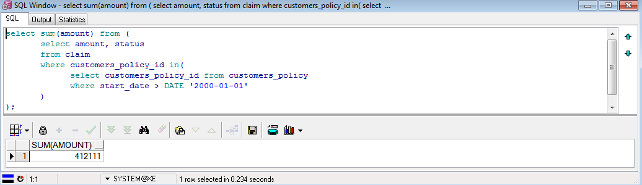
Then the Oracle server is stopped and started in order to clear the buffers, which prevents unwanted cache optimization from the previous querying and we create an index over the customers_policy.start_date, which will optimize the where statement in the aforementioned query:
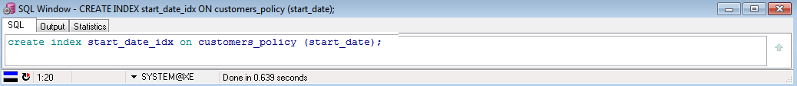
Finally, we run the query again. Notice the expected performance gain of 134ms (57%):
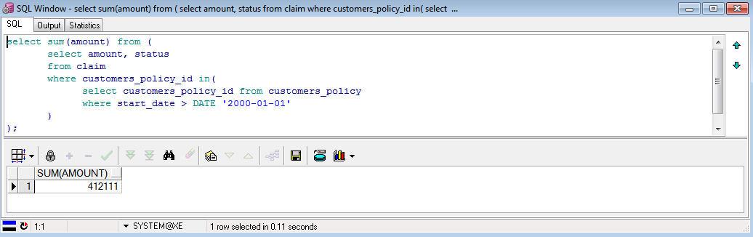
3. Update / delete:
1. Update customer’s email address:
update customer
set email = 'dacruz@anomel.com'
where customer_id = 237510106;
2. Update claim status:
update claim
set status = 0
where customers_policy_id = 153;
3. Delete claims related to customer’s policy 123:
delete claim
where customers_policy_id = 123;

4. And then delete the customer’s policy itself:
delete customers_policy
where customers_policy_id = 123;
4. Commit / rollback:
1. Commit
The customer’s policy record for ID 123 looks this way before and after deletion, as long as we don’t commit:
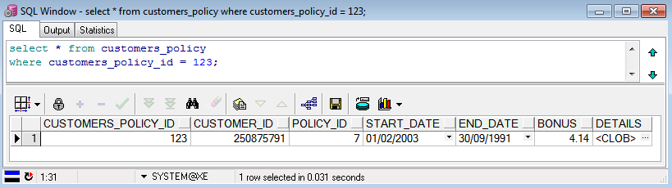
Then we execute the delete query and commit command:
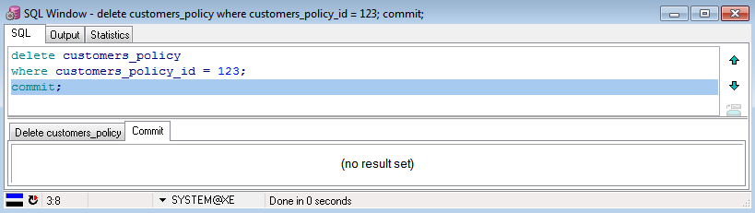
And this is what we get after commit:
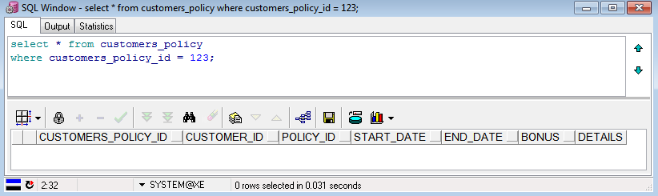
Of course, we can see that the customer’s policy record is now gone.
2. Rollback
This is what we get before deletion:
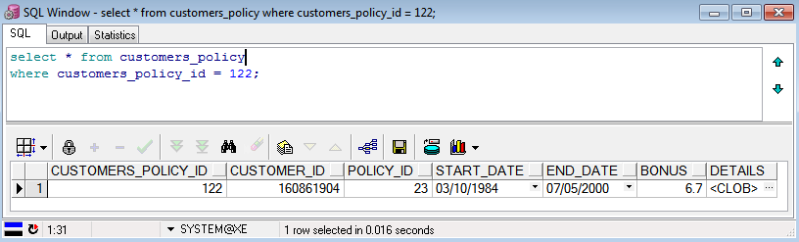

Then we delete and query:
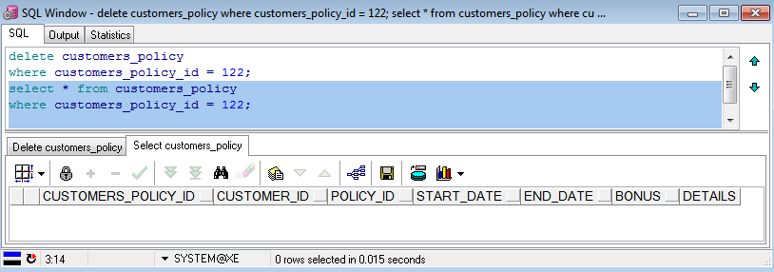
And finally rollback and query again:
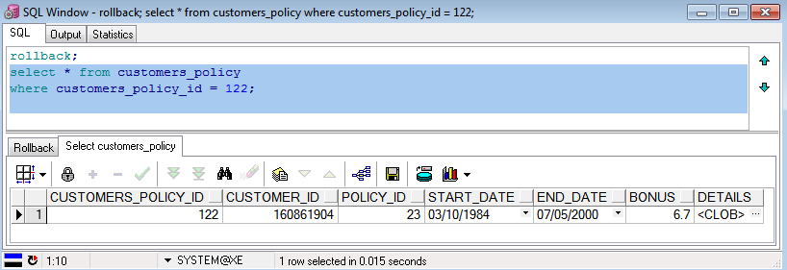
As we can see, the record has reappeared, just as expected.
5. Constraints
We define a new constraint, which checks that the customer_ID has 9 digits from 0 to 9, or in other words, that the customer_ID is strictly below 1000000000 (the lowest number with over 9 digits):
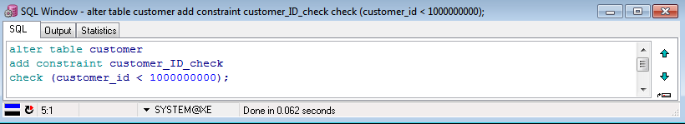

And now we update a customer’s ID with an illegal Id (1201547896, which has 10 digits):
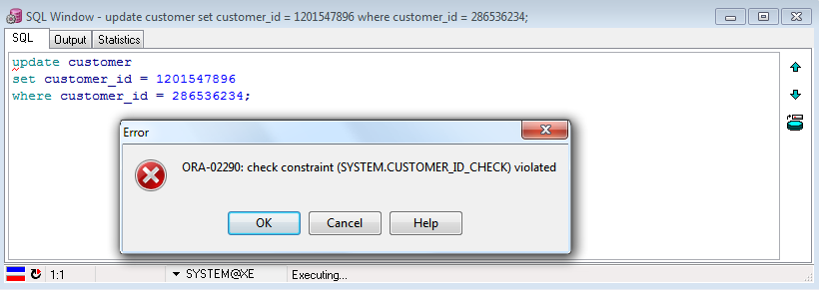
And as expected, the update is refused, because the constraint was violated.

